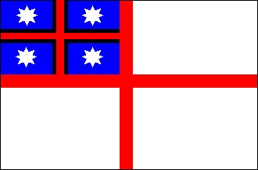
Tohu Of your Hapū and Tribal Area
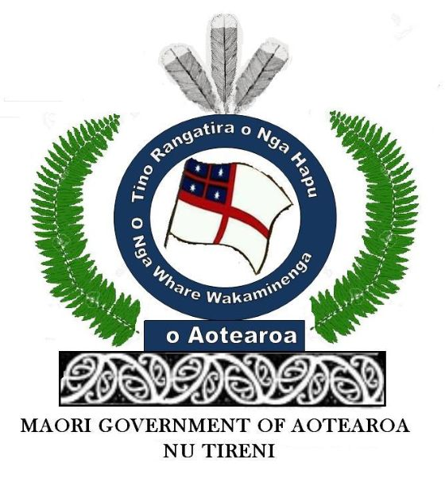

PUBLIC NOTICE OF PROCLAMATION
DATE________________________
TAKE NOTICE THAT WE, TE HAPU O TE WAKAMINENGA WAHI O _____________________________________________________________________
(name of Hapū and tribal area)
IN OUR NATIVE TRIBAL AUTHORITY OF (TE WAIARIKI) NATIONS PROCLAIM OUR ROHE TERRITORY TO BE;
Insert rohe territory

AND WE PUBLICALLY PROCLAIM OUR FULL RIGHTS, POWERS AND PRIVILEGES TO REIGN, RULE AND TO GOVERN IN OUR FULL CAPACITY OF LEGAL ADMINISTRATIVE GOVERNANCE PURSUANT TO OUR UNEXTINGUISHED ALLODIAL NATIVE TITLE TO OUR WHENUA OF TE WAIARIKI ROHE, PAPATUANUKU-NA-AOTEAROA THE DOMINION OF GOD, AND THAT WE INVITE ALL OTHER NATIVE ABORIGINAL TRIBAL NATIONS WITHIN THE SAID TERRITORY OF PAPATUANUKU-NA-AOTEAROA TO JOIN THIS WAKAMINENGA GENERAL ASSEMBLY.

Wakaminenga o Nga Hapu o Nu Tireni

Resolution 2 That in Full Rights Powers and Privileges of Native Sovereignty; Mana and Tino Rangatiratanga Legally constituted in accordance with “He Wakaputanga o te Rangatiratanga o Nu Tireni 1835” We, Ko matou ko nga Tino Rangatira o nga iwi o Nu Tireni i runga mai o Hauraki, ara KO TE HAPU O TE WAKAMINENGA WAHI O

_______________________________________________________________________________________________
(name of Hapū and tribal area)
in our Native Status having pre-existing rights in land property upon the Dominion of the Native Chiefs and Native Tribes, in our collective Capacity we adopt the 1948 UNIVERSAL DECLARATION OF HUMAN RIGHTS for our Tribal Sovereign Nation’s Territory
Moved: Seconder:
For…………. Against………………Abstained……………..Carried/Not Carried

DATE PASSED____________________

Resolution 3 That in Full Rights Powers and Privileges of Native Sovereignty; Mana and Tino Rangatiratanga Legally constituted in accordance with “He Wakaputanga o te Rangatiratanga o Nu Tireni 1835” We, Ko matou ko nga Tino Rangatira o nga iwi o Nu Tireni i runga mai o Hauraki, ara KO TE HAPU O TE WAKAMINENGA WAHI

______________________________________________________________________________________________
(name of Hapū and tribal area)
as recognized in the protectorate Statutes in Westminster we therefore proclaim that: in our Native Status having pre-existing rights in land property upon the Dominion of the Native Chiefs and Native Tribes, in our collective Capacity we also refer to Whenua Tuku Iho as Dominion of Papatuanuku-na-Aotearoa, and/or “Dominion of God” as our pre-existing property rights many thousands of years before the presumptions made by both Abel Tasman and Captain James Cook’s pretended doctrines of discovery conveyance survey claims to their Paper Maps or Paper Titles masquerading as the Actual, and to say that their fictitious paper titles in the form of pretended conveyances or pretended conveyances leases or whatever their “Straw land” represents, are synonymous to Fictitious Conveyances, in that all paper titles created by the British Citizen’s unconstitutional Native Land Courts since 30th October 1865 (their Courts having no de jure standing, and the 1860 Land Registry Act, 1865 Native Lands Act, 1870 Land Transfer Act, which was legislative theft saw millions of acres transferred to Pakeha (and derivatives of European) ownership, was ultra vires the 1835 Wakaputanga Constitution for the conversion of traditional communal landholdings into Pakeha (and derivatives of European) individual titles, such fraudulent conveyances are null and void ab initio as the onus of proving extinguishment lies on the Crown and the necessary purpose must be clear and plain [148] 2003 Court of Appeal, Seabed Foreshore Case; thus rebutting the presumption that the land titles of the “State of New Zealand Corporation” are fictitious ab initio therefore reaffirming our unextinguished inalienable allodial aboriginal native title of tangata whenua tuku iho to Hawaiiki tautau, ko Papatuanuku-na-Aotearoa.

Moved: Seconder:
For…………. Against………………Abstained……………..Carried/Not Carried

DATE PASSED_________________________

